# **QUANTANICS TECHSERV PRIVATE LIMITED -MADURAI**

# **DOMAIN: DATABASE MANAGEMENT SYSTEM**

## **PROJECT: ENERGY-METER PREDICTOR**

## 

**CONTENTS**

* SOFTWARES REQUIRED
* INSTALLATION OF RASPBERRY PI OPERATING SYSTEM
* INSTALLATION OF ADVANCE IP SCANNER
* INSTALLATION OF VNC VIEWER
* TO CONNECT WITH RASPBERRY PI OS
* ABOUT MQTT
* INSTALLATION OF MQTT
* EXECUTION OF MQTT
* DATABASE MANAGEMENT SYSTEM
* ABOUT SQL
* ABOUT MYSQL
* ABOUT XAMPP
* INSTALLATION & EXECUTION OF XAMPP
* ANOTHER WAY TO CREATE DATABASE
* ABOUT GRAFANA
* DISPLAYING THE DATABASES IN GRAPHICAL VIEW
* INTEGRATING THE MQTT PROTOCOL’S DATA WITH THE

MYSQL DATABASE

* REFERENCE

**SOFTWARES REQUIRED**

* RASBERRY PI OS
* ADVANCED IP SCANNER
* VNC VIEWER
* MQTT BOX
* XAMPP CONTROL PANEL
* GRAFANA APPLICATION
* PYTHON IDLE

# **INSTALLATION OF RASPBERRY PI OPERATING SYSTEM:**

**STEP 1**: OPEN WEB BROWSER AND TYPE “RASPBERRY PI OS INSTALLATION” AND CLICK THIS LINK (https://www.raspberrypi.com/software)

**STEP 2:** YOU CAN SEE THE (RASPBERRY PI IMAGER) AND SELECT THE OS TYPE AND VERSION

**STEP 3:** INSERT THE SD CARD TO YOUR COMPUTER

**STEP 4:** AFTER INSTALLATION RUN THE RASPERRY PI IMAGER IT SHOWS TWO OPTIONS AS SHOWN BELOW

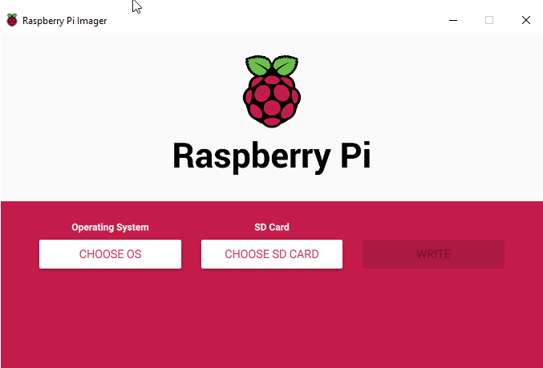

**STEP 5:** NOW CLICK THE "CHOOSE SD CARD" OPTION AND SELECT THE TARGET SD CARD

**Note:**

1. **IF YOU CHOOSE OS YOUR COMPUTER OS CAN BE ERASED**
2. **IT IS RECOMMENDED OF 32-BIT PROCESSOR**
3. BE PATIENT AND WAIT FOR THIS PROCESS TO COMPLETE. IF YOU REMOVE THE SD CARD, UNPLUG THE CARD READER, OR SHUT DOWN THE COMPUTER AT ANY POINT DURING THIS PROCESS, THE CARD WILL BECOME BRICKED AND UNUSABLE.

**STEP 7**: WHEN THE VERIFICATION PROCESS IS COMPLETE, A NOTIFICATION WINDOW WILL OPEN LETTING YOU KNOW THAT THE WRITE WAS SUCCESSFUL

**STEP 8:** AFTER FLASH THE RASPBERRY PI OS IS BOOTED TO YOUR SD CARD AND THAT IT'S NOW SAFE TO REMOVE THE SD CARD.

**STEP 9:** INSERT THE MEMORY CARD IN THE SLOT OF THE SUITABLE PORT.

**INSTALLATION OF ADVANCE IP SCANNER**

**STEP 1:** OPEN WEB BROWSER AND COPY THIS LINK (https://www.advanced-ip-scanner.com/ ) AND PASTE IT. THEN CLICK ENTER

**STEP 2:** YOU CAN SELECT THE OS TYPE AND VERSION TO DOWNLOAD

**STEP 3:** AFTER DOWNLOAD OPEN SEARCH BAR AND TYPE ADVANCE IP SCANNER YOU CAN SEE THE ADVANCE IP SCANNER IS SUCCESSFULLY INSTALLED

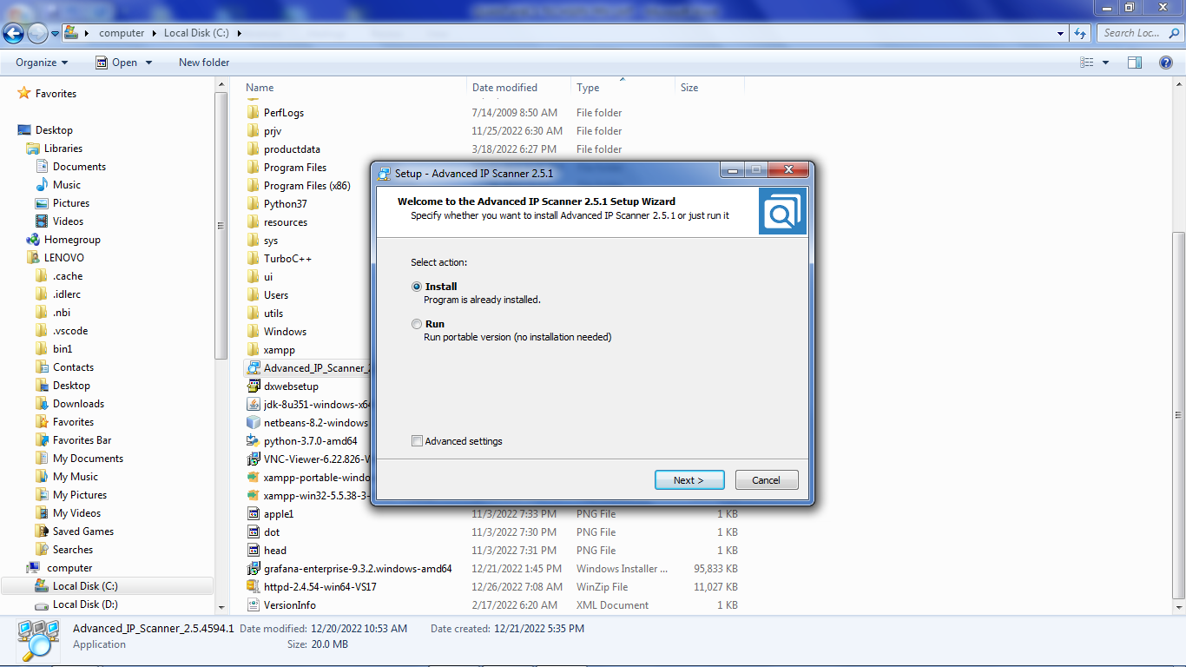

**INSTALLATION OF VNC VIEWER**

**STEP 1:** OPEN WEB BROWSER AND COPY THIS LINK (https://www.realvnc.com/en/connect/download/viewer/ ) AND PASTE IT. THEN CLICK ENTER

**STEP 2:** YOU CAN SELECT THE OS TYPE AND VERSION TO DOWNLOAD

**STEP 3:** AFTER DOWNLOAD OPEN SEARCH BAR AND TYPE VNC VIEWER YOU CAN SEE THE VNC VIEWER IS SUCCESSFULLY INSTALLED

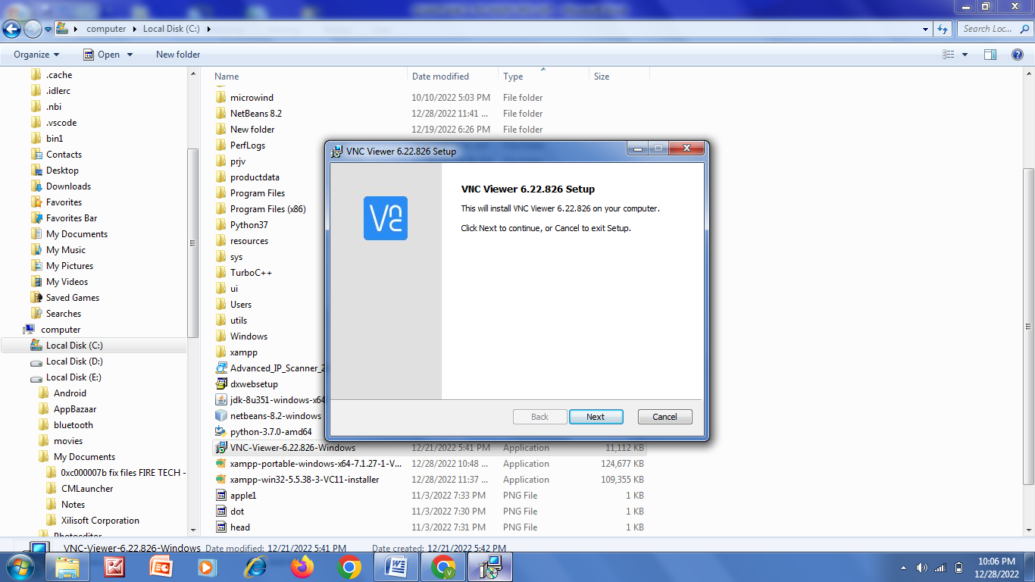

**TO CONNECT WITH RASPBERRY PI OS:**

**STEP 1:** OPEN THE ADVANCE IP SCANNER

**STEP 2:** ENTER THE IP ADDRESS “192.168.29-254” IN THE SEARCH BAR AND HIT ENTER

**STEP 3:** SELCT AND COPY THE LINK OF (192.168.29.102) RASPBERRY MANUFACTURER IN THE WINDOW

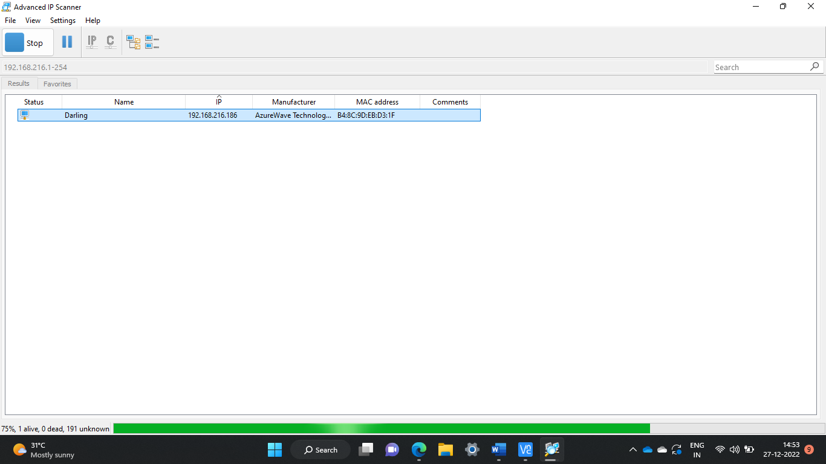

**ADVANCE IP SCANNER**

**STEP 4:** OPEN THE VNC VIEWER APPLICATION AND PASTE THE LINK IN THE SEARCH BAR AND HIT ENTER.

**STEP 5:** ENTER THE USERNAME AND PASSWORD AS “PI” AND “RASPBERRY” RESPECTIVELY.

**STEP 6:** THE VIRTUAL SPACE FOR THE LINK WILL BE CREATED AND WE CAN EXECUTE THE TASK

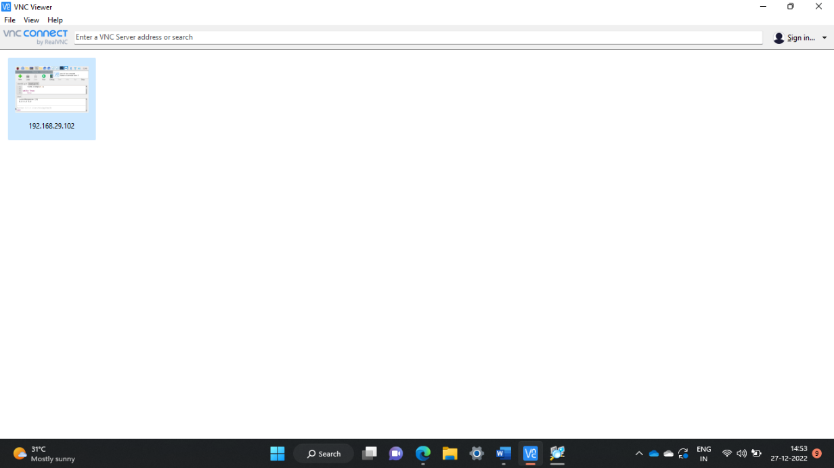

**VNC VIEWER**

**************************************************

**ABOUT MQTT**

**[Message Queuing Telemetry Transport]**

* It is a machine-machine protocol, i.e., It provides communication between the devices.
* It is designed as a simple and lightweight messaging protocol that uses a publish/subscribe system to exchange the information between the client and the server like how YouTube channels and their subscribers works
* It does not require that both the client and the server establish a connection at the same time.
* It provides faster data transmission.
* It allows the clients to subscribe to the narrow selection of topics so that they can receive the information they are looking for.

## **INSTALLATION OF MQTT**

**STEP1**: OPEN MS STORE

**STEP 2:** TYPE “MQTT BOX” AND CLICK “GET” TO INSTALL THE APPLICATION.

## **EXECUTION OF MQTT**

* IT’S A JSON APPLICATION AND DATA WERE DISPLAYED IN DICTONARY FORMAT (KEY AND VALUE)
* CREATE A NEW CLIENT ID
* ENTER THE CLIENT NAME AS YOUR WISH
* SELECT THE PROTOCOL AS “MQTT/TCP”
* ENTER THE HOST AS (broker.emqx.io)(THIS HOST CAN BE ACCSSED GLOBALLY)
* HIT “SAVE” BUTTON AND YOUR CLIENT ID WILL BE CREATED.

**MQTT CLIENT SETTING**

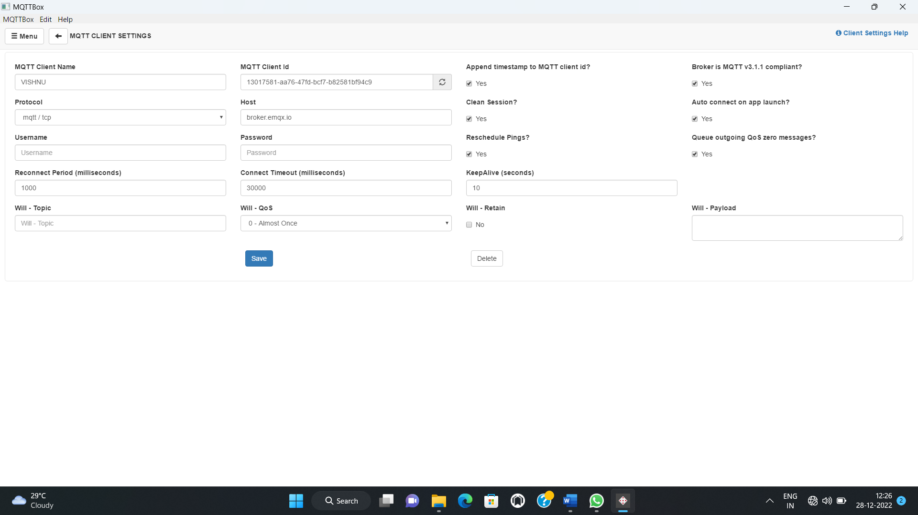

* NOW ADD THE SUBCRIBER AND ENTER THE TOPIC TO SUBCRIBE AS “energymeter/v1” AND HIT THE SUBCRIBE TAB.
* THE VALUES OF THE RESPECTED TOPIC WILL BE PUBLISHED TO YOUR ID.

**SUBSCRIBER WORKING**

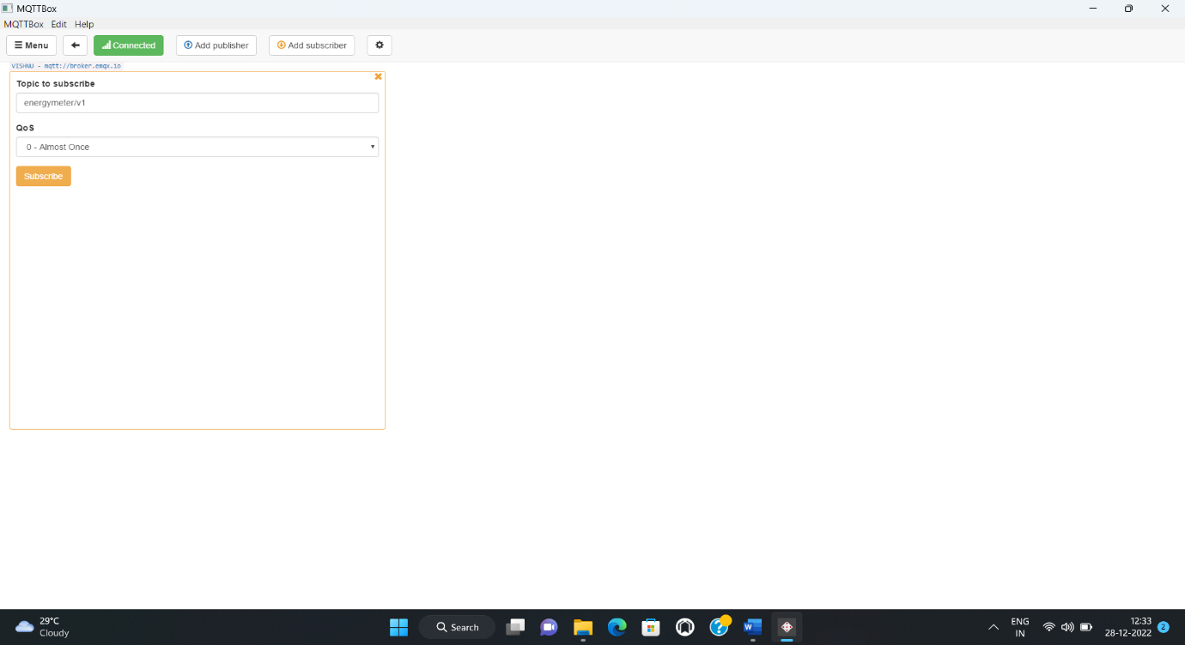

**WORKING OF MQTT INTERNALLY**

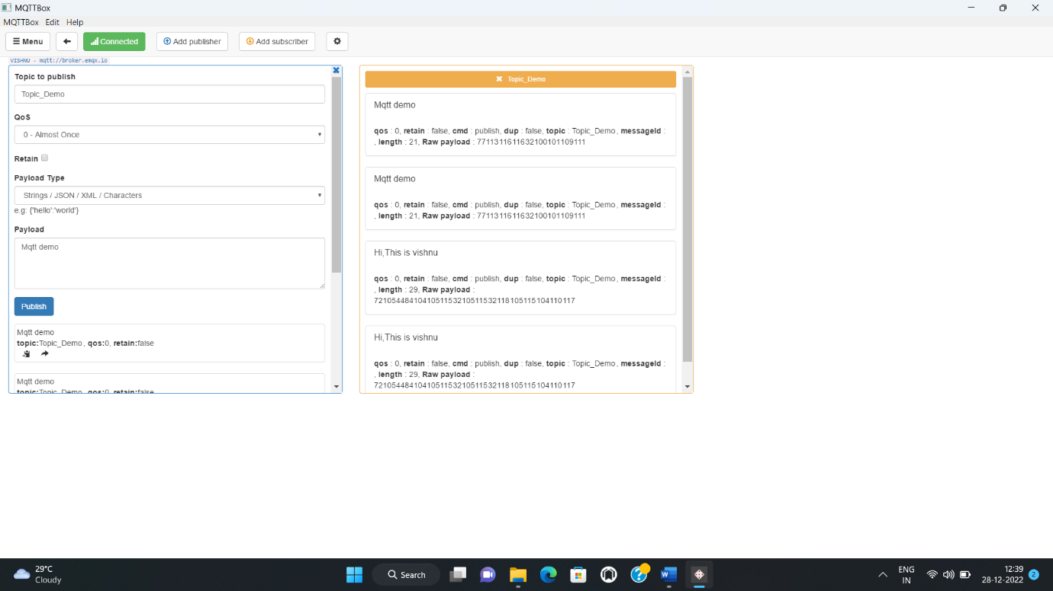

THE “#” IS USED TO ACCESS ALL THE MESSAGES THAT ARE CONNECTED TO SAME HOST

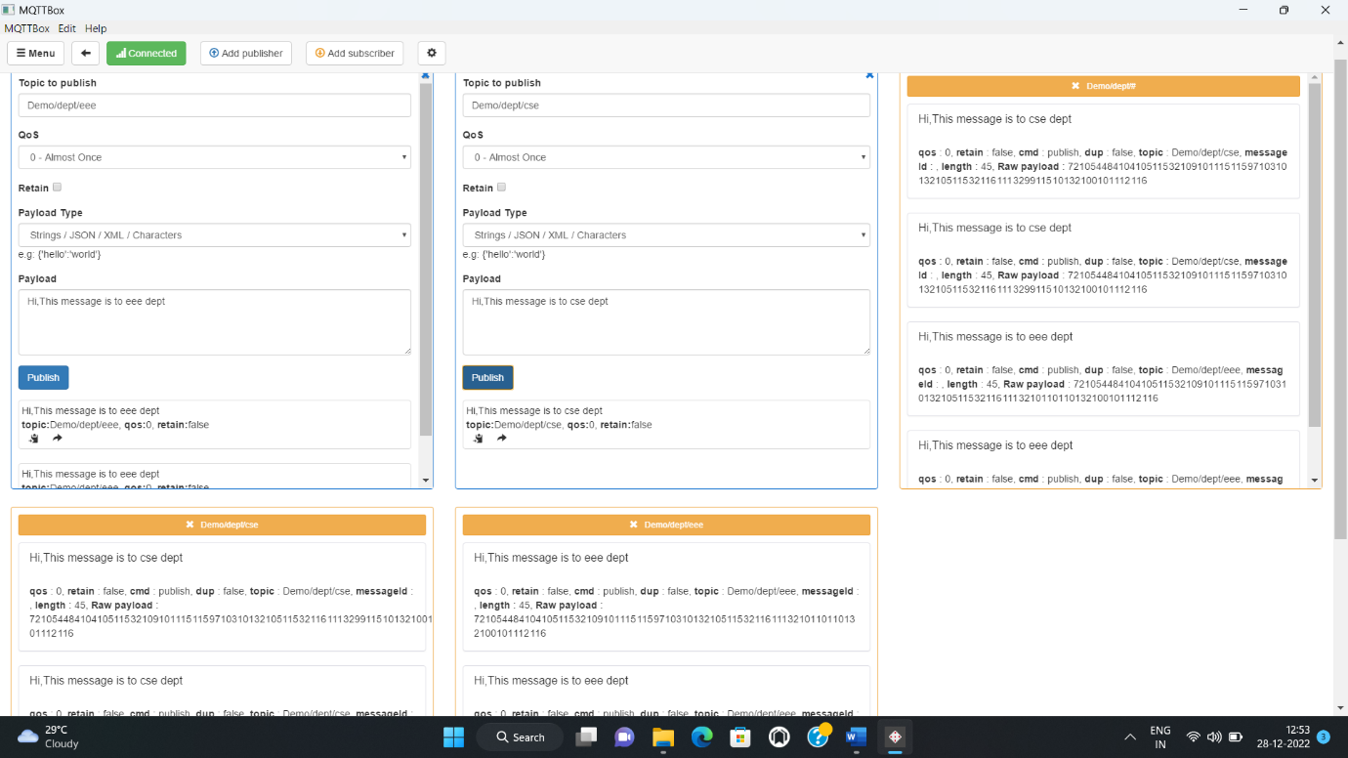

**DATABASE MANAGEMENT SYSTEM**

* A database management system (DBMS) refers to the technology for creating and managing databases.
* DBMS is a software tool to organize (create, retrieve, update, and manage) data in a database

**ABOUT SQL**:

* SQL stands for Structured Query Language,
* Designed specifically for interacting with relational databases.
* SQL is a language for storing, manipulating, and retrieving data in relational database management systems.
* You can use the SQL language to modify and create tables in the database, insert new data, modify existing data, delete data from the tables, and query those tables for specific information.

**ABOUT MYSQL**:

* MySQL is a relational database management system.
* You use it to store data in tables, and the rows of those tables can be related to each other by common information in the columns.
* The basic idea is that you have one or more "tables" (or "databases") and a set of rows (records) and columns (fields).
* Other elements, like keys and indexes, help you define them further.

TASK: CREATE AND STORE A DATABASE USING MYSQL

SOFTWARE REQUIRED: XAMPP CONTROL PANEL

**ABOUT XAMPP:**

* It is initially released in 4th sep,2002
* XAMPP Stands for

X-Cross Platform

A-Apache

M-Maria DB

p-PHP

p-Perl

* XAMPP is a free and open-source cross platform
* It is the Integration of MariaDB, PHP and Perl

**INSTALLATION & EXECUTION OF XAMPP**

**STEP1**: Open web browser and type “XAMPP Control Panel download” and go through this link( <https://www.apachefriends.org/download.html>)

**STEP 2:** Open the website and select the download link suitable for your OS

**STEP 3**: Install the application in your system.

**STEP 4:** Search the XAMPP Application in Search Button and Open it

**STEP 5:** Press the START icon of the respective modules to execute their services.

(Here we are going to Start the “Apache” and “MySQL” modules).

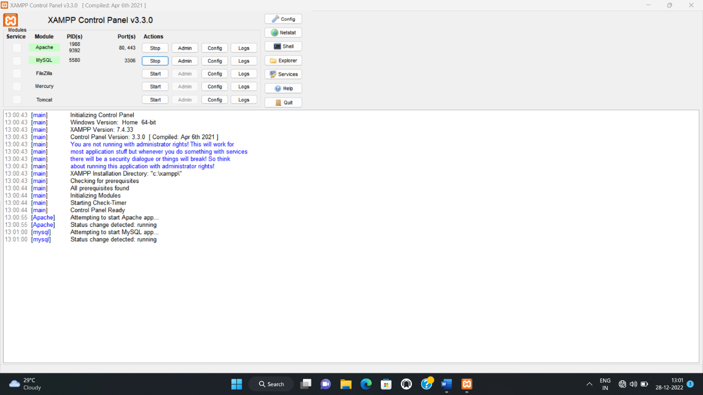

**STEP 5**: Open the browser and type ‘localhost/PHPmyadmin ’(the link will be directed us to the Apache website to create database)

**STEP6:** Create a new database and create a table within that database.

**STEP 7:** Create columns by specifying name, datatype and length for each column.

**STEP 8:** Insert the data and press ‘GO’ icon.

***************************************************************************

**YOUR DATABASE HAS BEEN CREATED AND DISPLAYED IN TABLE SECTION**

***************************************************************************

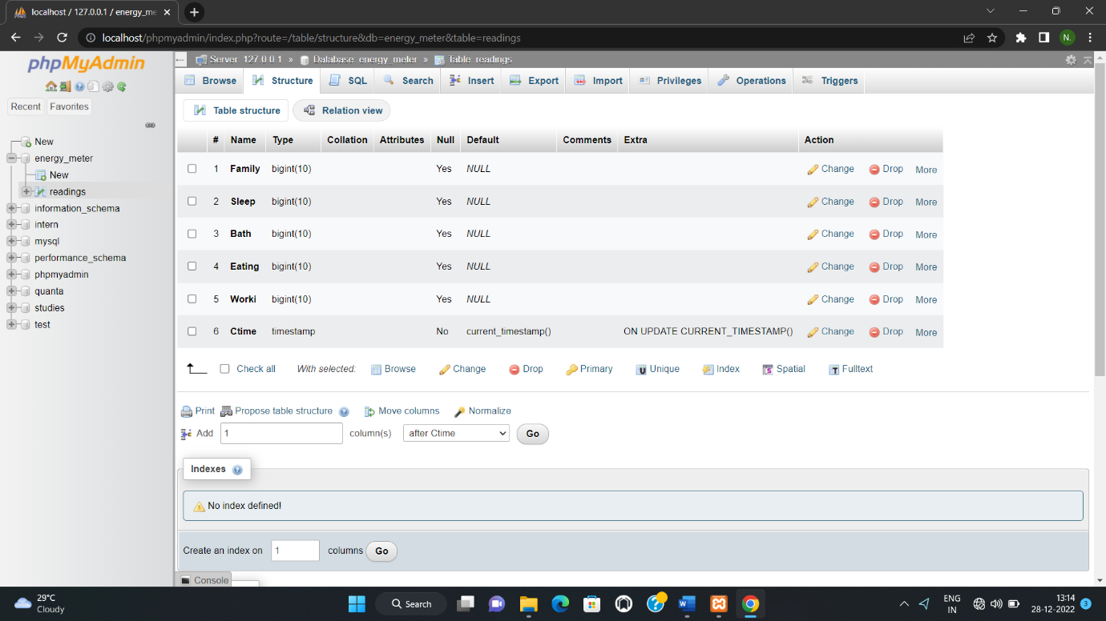

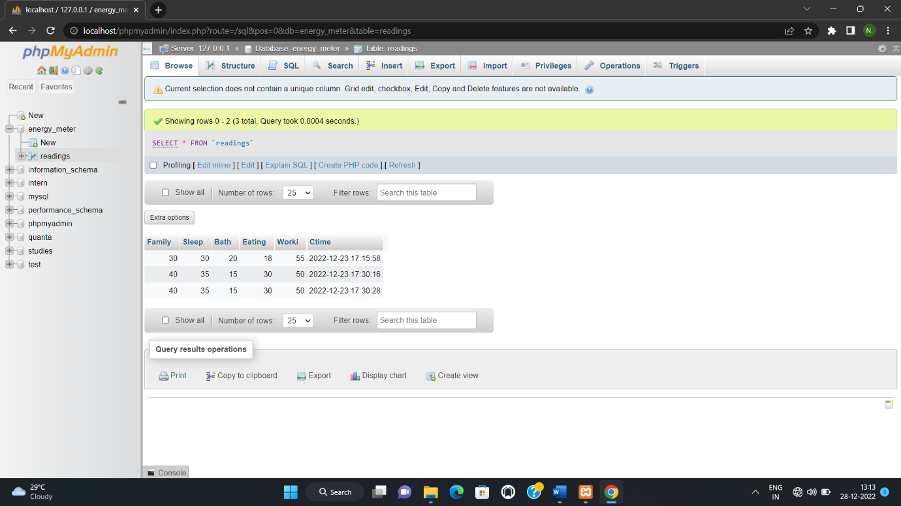

**ANOTHER WAY TO CREATE DATABASE**

**[BY WRITING SQL]**

* It works on [CRUD]

C-Create

R-Read

U-Update

D-Delete

* In PHPmyadmin select “SQL” TAB and write the following commands to create database

**STEP 1:** To Create a new Database

[CREATE DATABASE database-name]

**STEP 2:** To Create a new table

[CREATE TABLE database-name (column_name1 type(value), column_name2 type(value), column_name3 type(value)]

**STEP 3:** To Insert the Value

[INSERT INTO database-name ((column_name1, column_name2, column_name3)VALUES (value-1,value-2,value-3)]

**STEP 4:** To Update the value

[UPDATE database-name SET column_name=value, WHERE Row_number=value]

**STEP 5:** To Delete the value

[DELETE FROM database-name WHERE Row_number=value]

**EXAMPLE OF SQL**

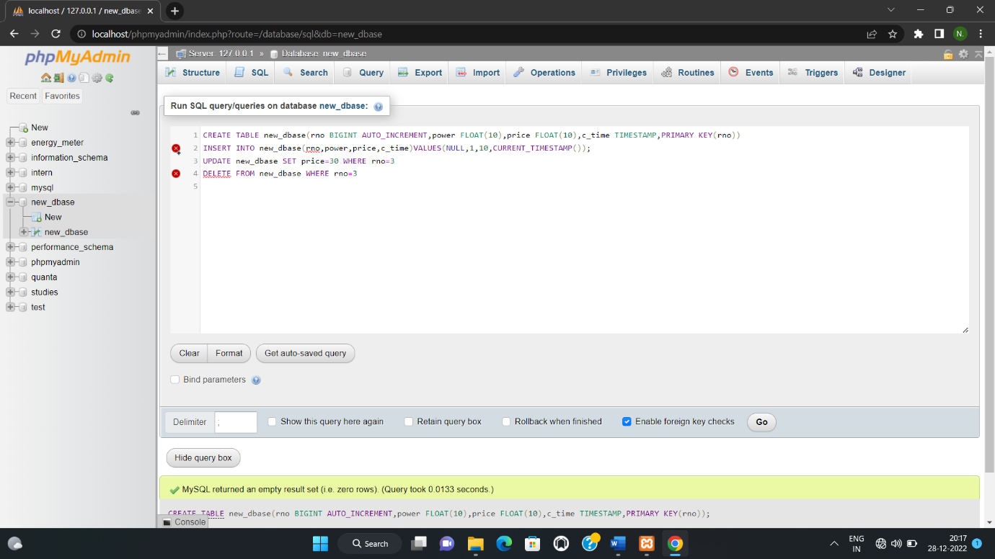

**DELETION OF ROW USING SQL**

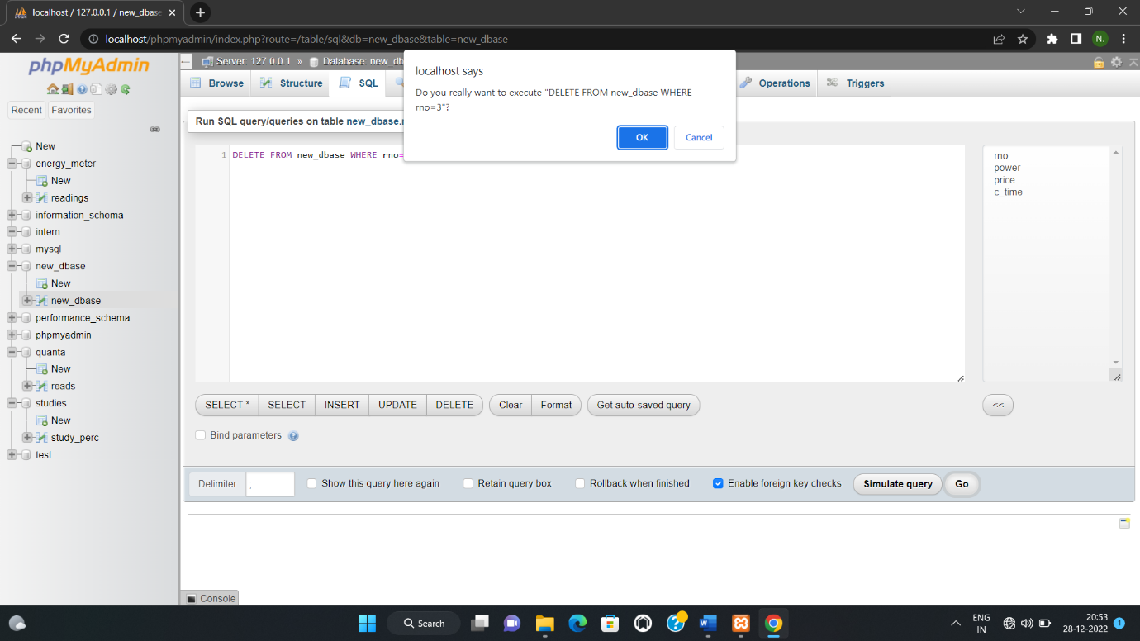

TO VERIFY DELETION AND CLICK “OK”TO DELETE

**DATABASE IS CREATED USING SQL**

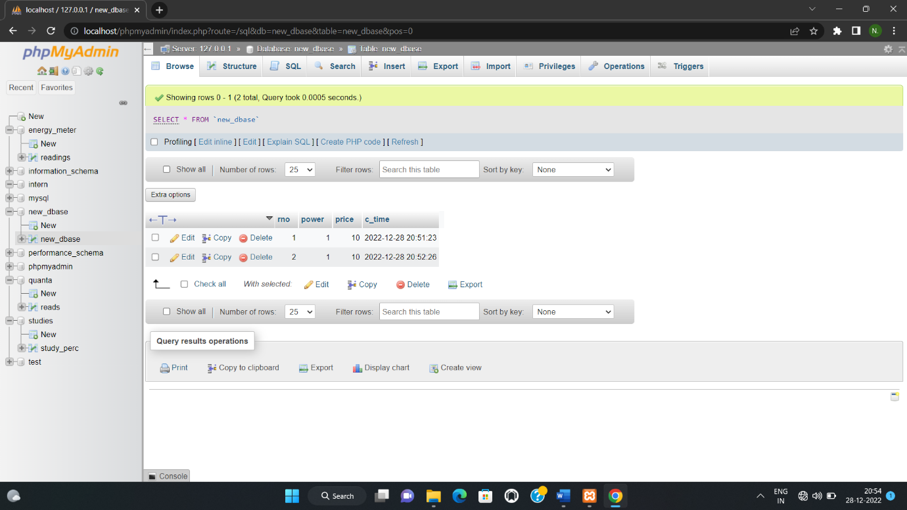

***************************************************************************

**ABOUT GRAFANA**

* Grafana is a multi-platform open-source analytics and interactive visualization web application
* It provides Charts, Graphs and alerts for the Web when connected to supported data source
* System development life cycle and provide continuous delivery with high software quality

**DISPLAYING THE DATABASES IN GRAPHICAL VIEW**

**SOFTWARE REQUIRED: GRAFANA**

**EXECUTION:**

**STEP 1:** Open browser and copy this link(<https://grafana.com/grafana/download>)and paste it to install Grafana in your system.

**STEP 2**: Open the service window and restart the Grafana application.

**STEP 3:** Open the browser and type ‘local host:3000/’ and it will be redirected to the Grafana website

**STEP 4:** Initially give the USER NAME and PASSWORD as “admin” and “admin” respectively

**STEP 5:** Give your own Password in New Password tab and access it by the same password

**STEP 6:** Click on settings icon on left side of the window and click the DATA SOURCES in the list.

**STEP 7:** Press the ‘add data source’ icon on right side to create new data source of MySQL

**STEP 8**: Fill the required data of

HOST:127.0.0.1

DATABASE: Your database name

USER: root

and click ‘save and test’ icon

[ your data source will be created]

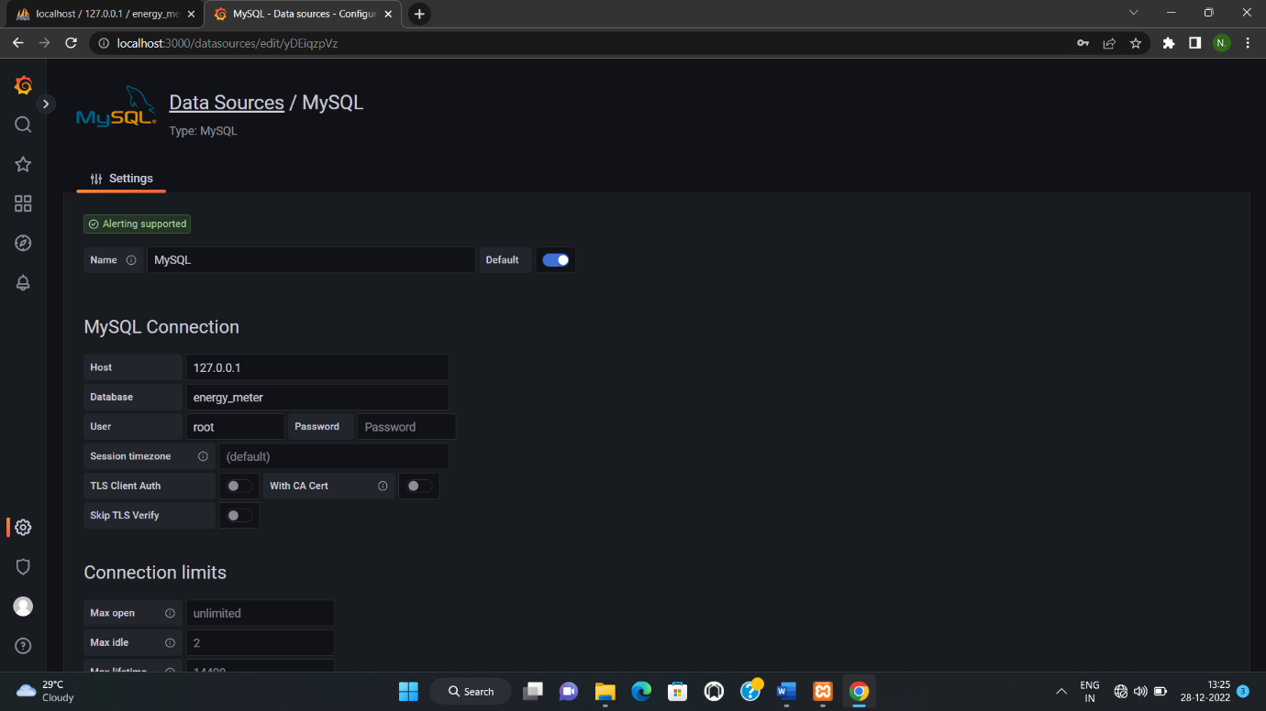

**STEP 7:** Click on the dashboard icon and select the new dashboard.

**STEP 8:** Select the new panel and fill respective information in query section such as:

* Data source
* Data set
* Table name
* Column name
* Aggregation
* Order

After Completing the Required data’s Click “Run query”

**STEP 9:** Select graphical representation option and click on save and apply icon

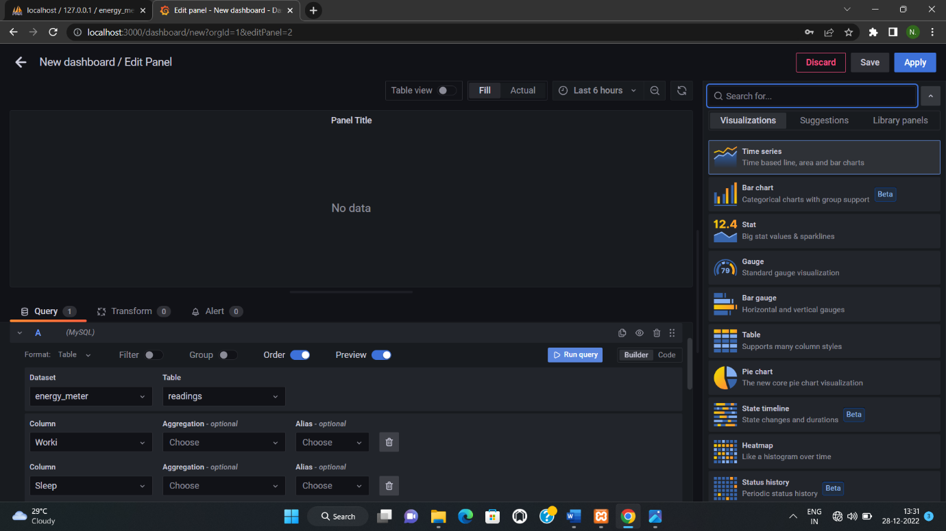

***************************************************************************

**THE OUTPUT WILL BE DISPALYED IN THE PANEL SCREEN**

***************************************************************************

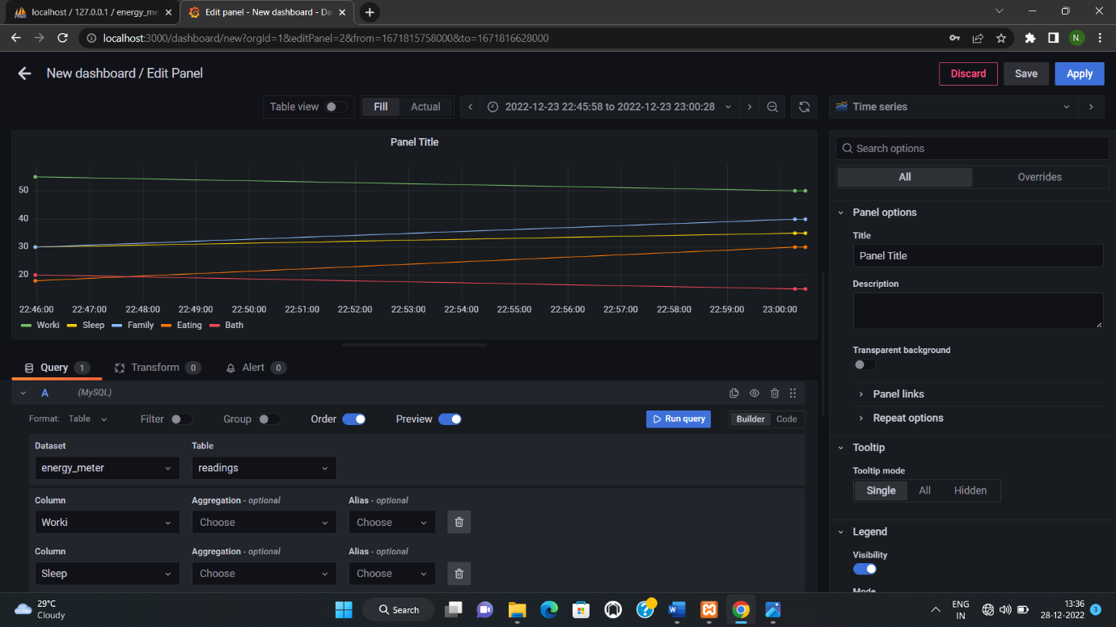

**MULTIPLE GRAPH IN THE SAME PANEL**

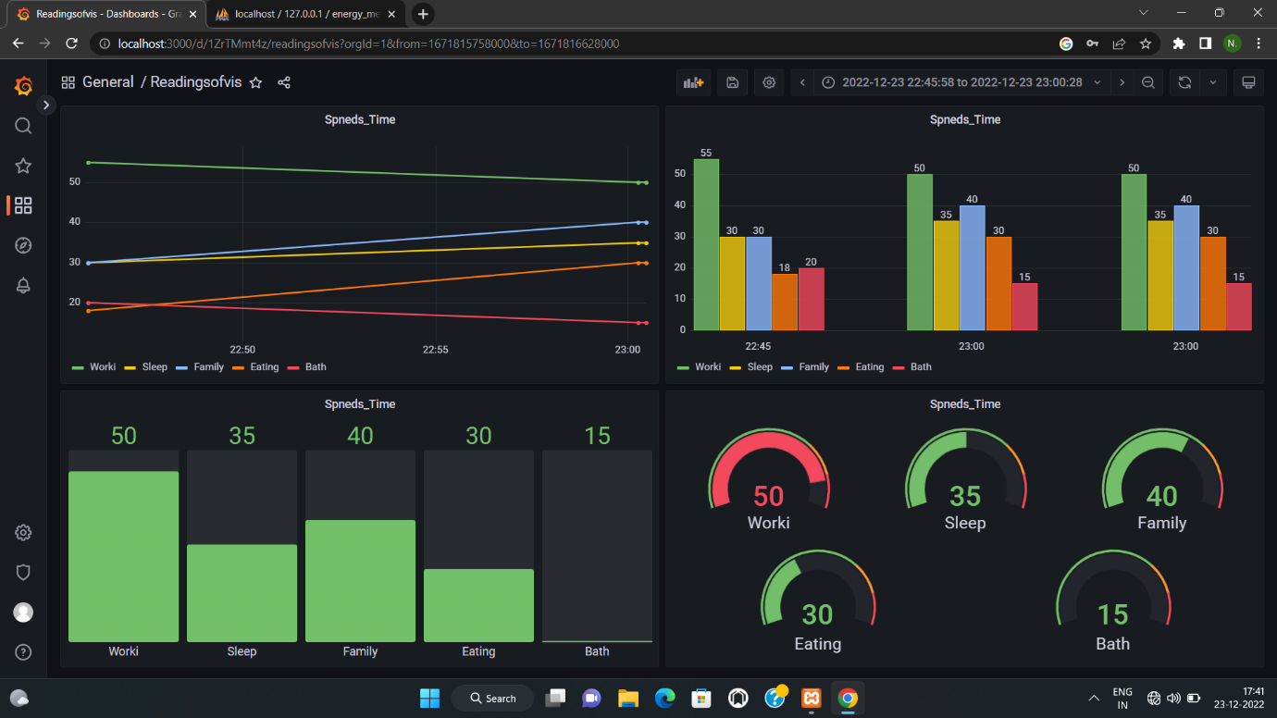

***************************************************************************

**EXAMPLES TO WORKOUT WITH THE XAMPP AND GRAFANA INTERFACE USING THE BELOW MENTIONED STEPS.**

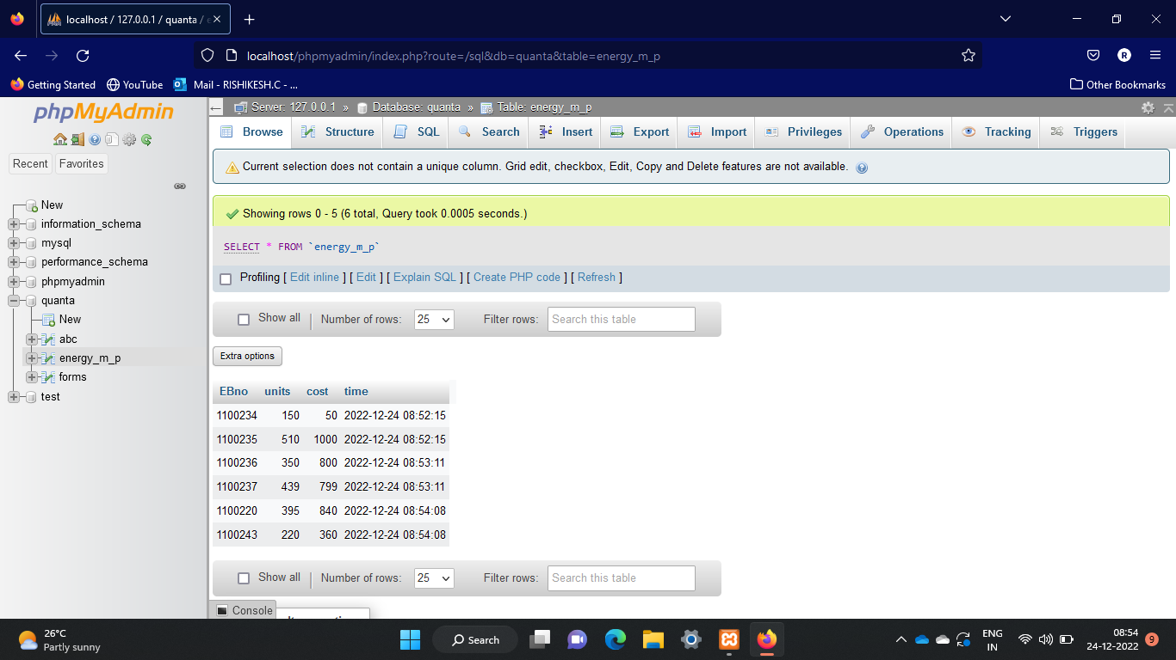

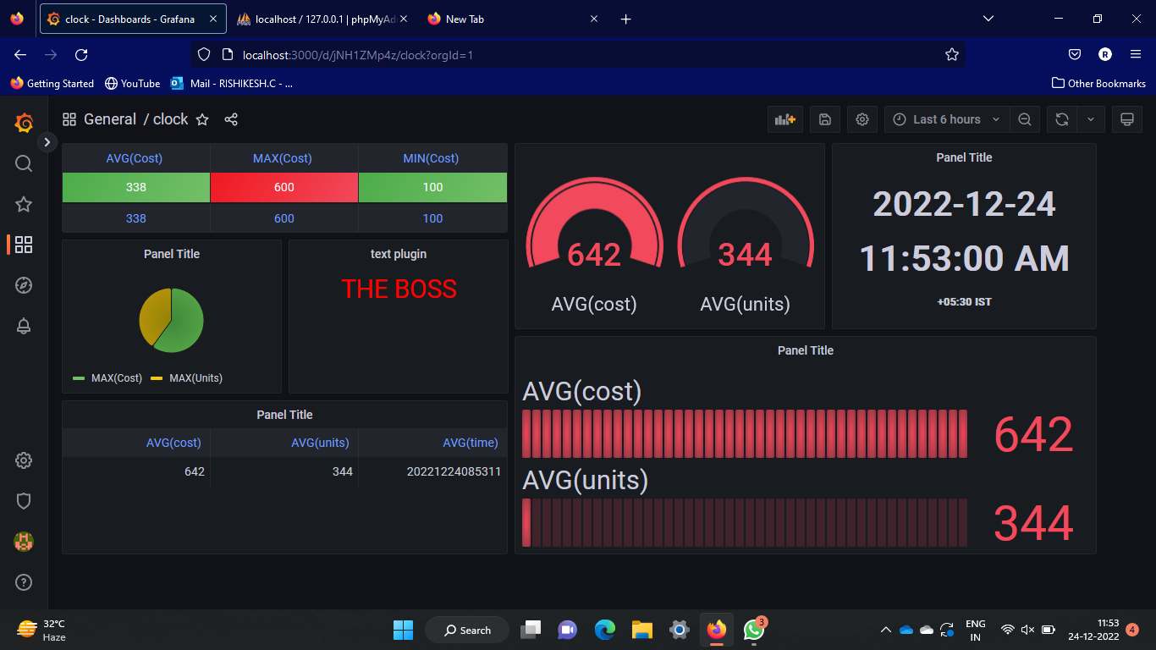

**INTEGRATING THE MQTT PROTOCOL’S DATA WITH THE MYSQL DATABASE**

**USING PYTHON CODE:**

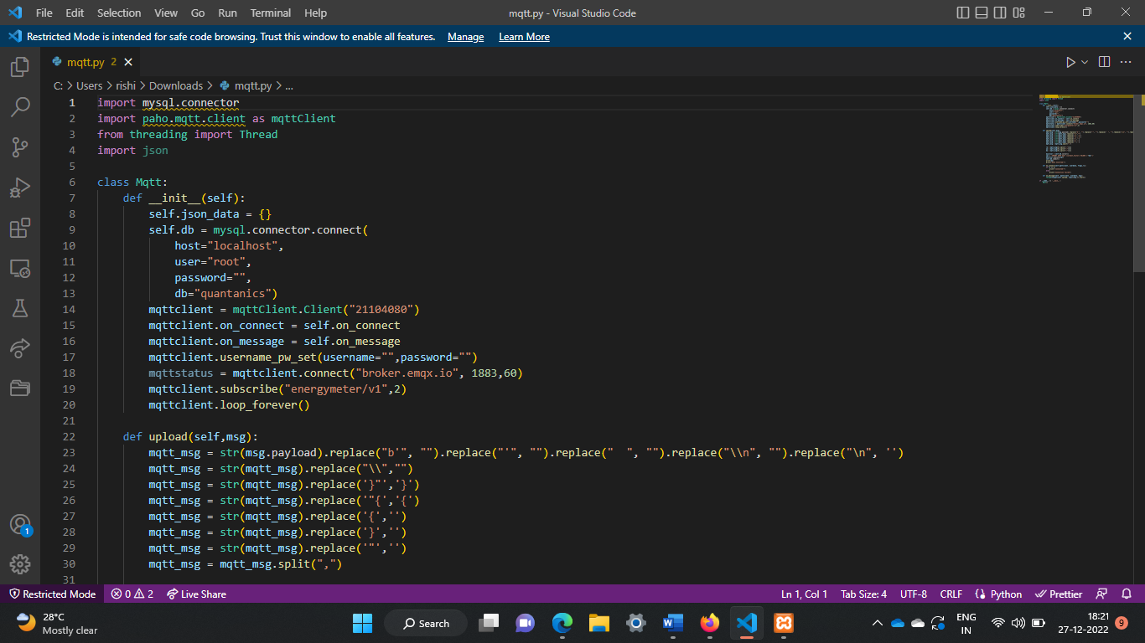

**DESCRIPTION**: THE DATA HAS BEEN INSERTED AUTOMATICALLY IN THE DATABASE FROM THE MQTT PROTOCOL USING THE PYTHON CODE WHICH IS RUN BY COMMAND PROMPT.

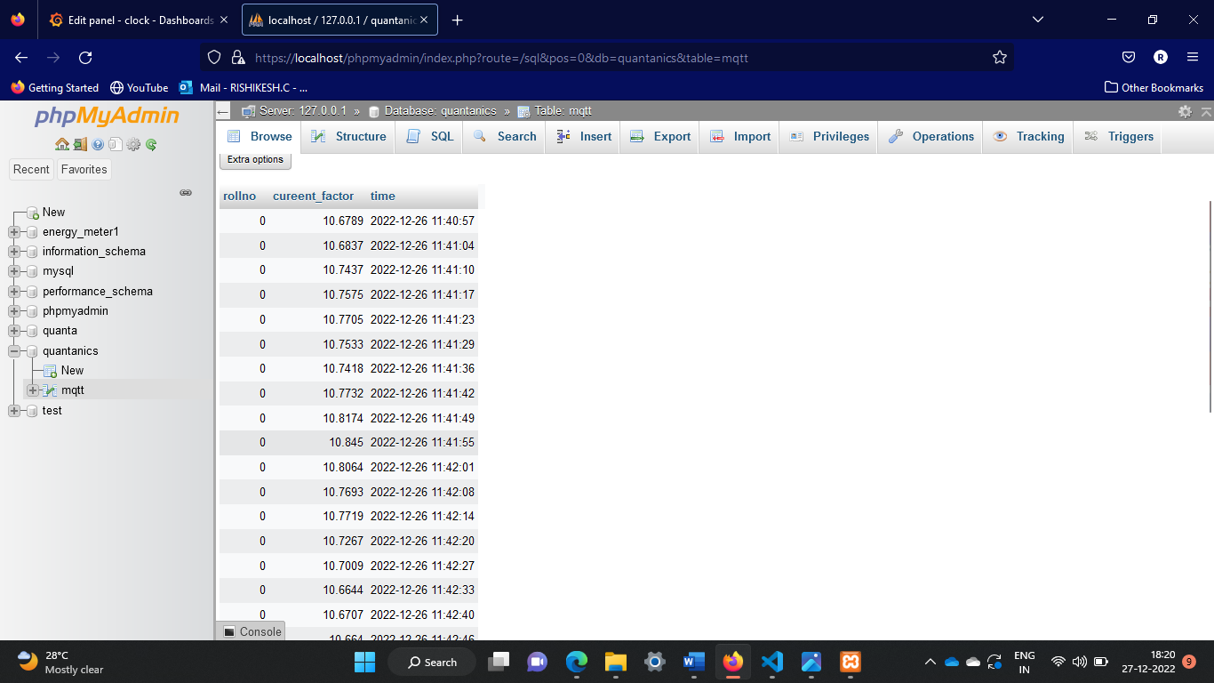

THE GRAPHICAL VIEW OF THE DATABASE IS DISPLAYED HERE AND THE GRAPH WILL BE UPDATE FOR EACH 5 SECONDS.

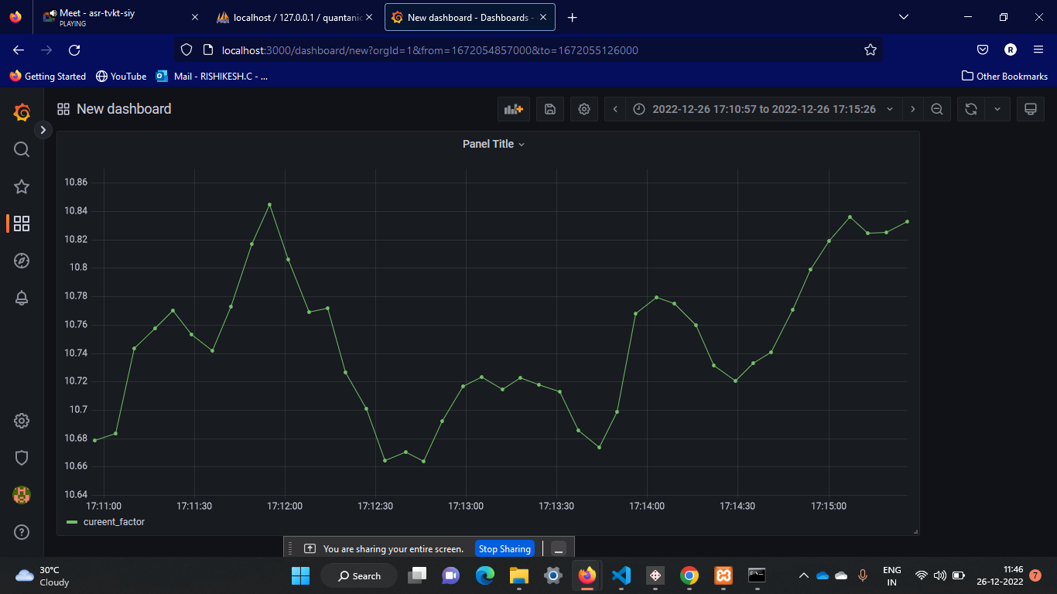

**REFERENCE**

Refer the below website

* tutorialspoint.com
* w3schools.com

for further studies

***************************************************************************

***THANK YOU***

***************************************************************************

**BY,**

**VISHNU N,**

**21UCS098-II YEAR CSE,**

**KAMARAJ COLLEGE OF ENGINEERING AND TECHNOLOGY,**

**VIRUDHUNAGAR**.